Minutes of the General Meeting of the Comstock Grizzlies
Saturday June 19th @ 5:30 PM
Carl’s Saloon After Beer Bust

General information and attendance:

Meeting called to order @ 5:35 PM by President Ken

Beer Bust and Meeting Attendee’s:
Nathan, Ken, Dan, Tom, Jason, Thomas, Mike
Tat, Steve, Max, Dean, Kyle and
New Member Tony A,

Will, George, Martin, Tina, Robert, also some donations

Attendee’s: Several

May 2025 minutes were sent to group.

Motion to approve as sent.
Motion: Tat Second Thomas Approved by acclimation.

Current information for these minutes.
Treasurers Report: Through 06/15/2025

Previous Balance: $ 530.46
Transactions: IN $ 00.00
Ending Balance: $ 530.46
Net Change: $ + 00.00
NO CHANGE

Motion to approve the Treasury Report.
Motion: Tat Second Thomas Approved by acclimation.

Although dues are not required to attend activities.
We are all encouraged to renew your dues
and look at friends to become members.
Just so we have funds for our club expenses.

Web/Facebook Report:
FULLY UPDATED

Old Business:

Beer Bust Information
We had over 20 people attend this year.
We have 1 new member – Tony A.
We collected a total of $265
We paid out $60 for the beer and $40 for bar tip.
We reimbursed $60 to Nathan for food.
Total expenses $160
Left for the club was $105 given to Dean.

This information adjusted because of payment
by our NEW Member.

Thank you all for attending.

New Business:

None

Next Dinner Night Out (DNO) will be at:

We had multiple suggestions for DNO
So I have listed one for June, July and August

July 2025

Boulevard Pizza
1076 Rock Blvd #105, Sparks, NV 89431
Wenesday July 9th @ 6:30pm
Max to make reservation, if needed.

August 2025

Black Bear Diner
2323 South Virginia Street Reno, NV 89502
Wenesdau August 6th @ 6:30pm
Abe to make reservation.

Nathan made a suggestion to the group to please
bring cash in case a restaurant does not allow separate checks. We will still always ask if they can do it.
Thank you,
Pot Luck Dinner and Club Meeting – Typically the 3rd
Saturday of the month

There was a suggestion and discussion on having
a theme for our dinners. After discussing we decided
to give it a try. It is a meal suggestion, not a requirement.
Just have FUN with it. Feel free to bring what you wish.

Next Meetings:
We are also planning ahead for the next 4 meetings.
June, July, August, September 2025

July Meeting and Pot Luck
Nathan and Ken’s Home Sparks
Saturday July 19th @ 6:30pm

Theme for this dinner is BBQ.
Ken and I will be providing
BBQ Chicken and Grilled burgers.
No need for main dishes unless you wish something for yourself.

Please bring side dished for a BBQ.

August Meeting and Pot Luck
Location Dan and Tom’s Home
Carson City, NV
Saturday August 16th @ 2pm

No theme for this dinner.

September Meeting and Pot Luck
Nathan and Ken’s Home Sparks
Saturday September 20th @ 6:30pm

No theme for this dinner.

Hope to see you all there.

Close the meeting:
Motion: Tat Second Thomas, Approved by acclimation.
Approved at 5:45 PM.

Respectfully Submitted
Nathan C. Secretary July 2, 2025

SPRING AND SUMMER PLANNING INFORMATION

GAME NIGHT AND ICE CREAM SOCIAL (NO DINNER)

Hosted by Nathan and Ken.
Planned for Wed July 16 @ 6:30pm
No need to bring anything.
I’ll be over doing it and we should have plenty.

MAGIC CARPET MINI GOLF

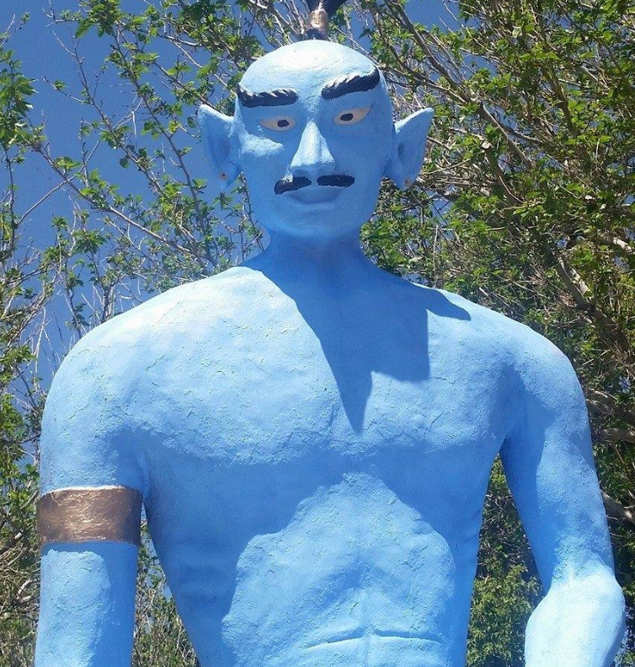
6925 S. VIRGINIA ST. RENO, NV 89511
COST $13 Cash $13.52 Card.
Planned for Wed July 23 @ 6:30pm

TRIP TO NEVADA MUSEUM OF ART

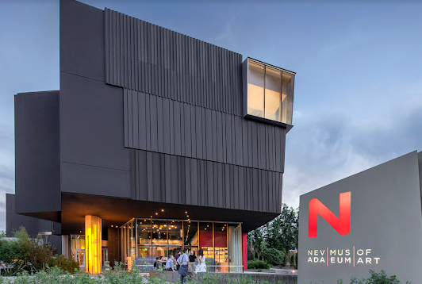

This outing would need to be on a Thursday and start earlier (5pm) do to their hours. Cost $15
I have asked Thomas to host this outing. Members will need to get with him to coordinate and confirm you are attending.
I have planned it for Thu Aug 14 @ 5pm due to their hours

TRIP TO RENO ANIMAL ARK

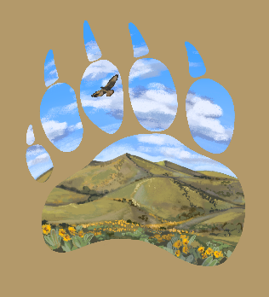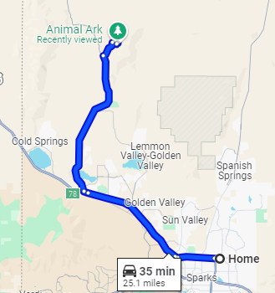
1265 Deerlodge Road. Reno, NV

This should be planned for a Saturday or Sunday.
Morning is best for viewing animals. Cost $20 / $16 Seniors.
Tickets only available online.
It is a 35 minute drive for our house so carpooling is suggested.
This will planned for Sunday Aug 24 @ 10:30am. Planning early start so it is not to hot and it is best time to see animals.
MONTH | DAY | DATE | TIME | NOTES
JUNE | WED | 4 | 6:30 | DNO MIGUELS
JUNE | WED | 11 | 6:30 | POKER NIGHT @ N&K
JUNE | SAT | 21 | 3 | MEETING AFTER BEER BUST @ CARLS
JUNE | THU | 26 | 5:30 | ACES GAME @ 6:30
JULY | WED | 9 | 6:30 | DNO BOULEVARD PIZZA
JULY | WED | 16 | 6:30 | GAME/ICE CREAM NIGHT @ N&K
JULY | SAT | 19 | 6:30 | MEETING BBQ @ N&K
JULY | WED | 23 | 6:30 | MAGIC CARPET MINI GOLF
AUGUST | WED | 6 | 6:30 | DNO BLACK BEAR DINER
AUGUST | THU | 14 | 0:00 | NEV MUSEUM HOST THOMAS
AUGUST | SAT | 16 | 6:30 | TBD
AUGUST | SUN | 24 | 10:00 | ANIMAL ARC - CAR POOLING
SEPTEMBER | SAT | 20 | 6:30 | MEETING POT LUCK @ N&K

EVERYTHING IS PLANNED BUT COULD CHANGE IN THE FUTURE.

